Xcode 9 Bug 2 - Cannot Drag to SCNAssets

**Every time Xcode updates it's interface, it comes with its fair share of bugs.**

**If you're unable to drag the Dae/SCN file into your scnassets folder, simply do the following.**

(This is an example from the Ikea section, but the process is the same)

Right click on your scnassets folder

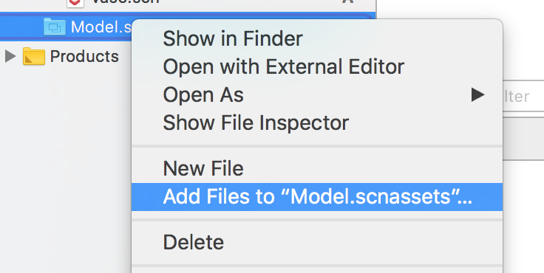

Add your dae/scn file manually with **Add Files to**

If for some reason, your models don't show up.

Close your Xcode project,

Open it Again.

You'll notice that nothing happened. However now, you should be able to add/drag them.

